Modeling & Measuring the Clustering of Cells in MOFs

An Independent Study Submitted to the Faculty of
The Department of Electrical and Computer Engineering Villanova University

By
Nicholas A. Florio
In Partial Fulfillment
of the Requirements for the Degree of Master of Science in Electrical Engineering


May 11, 2021

Independent Study Approval Form, with approving signatures

Acknowledgement

Abstract

Contents
1. Introduction 6
2. Approaches to Filtering Microscopy Images of Cells 6
2.1 Basic Cell Counting and Segmentation in MATLAB | Pedro Segmentation 6
Figure ##: Pedro Segmentation Progression 6
2.2 Image Segmenter App 7
2.3 Granulometry | Granulometry of Snowflakes 7
Figure ##: Snowflake Granulometry Progression 7
2.4 Edge Detection | Detect Cell Using Edge Detection and Morphology 8
Figure ##: Edge Detection Progression 8
3. Integration & Results 8
3.1 Pedro Segmentation 9
3.1.1 Sample Code Verification | BasicCellSegm_PedroFoundational 9
Figure #.#: Comparison of Example Code Results to BasicCellSegm_PedroFoundational 9
3.1.2 PNAS Images Implementation 9
Figure #.#: pnasimage1 Implementation 10
Figure #: pnasimage2 Implementation 10
Figure #: pnasimage3 Implementation 11
Figure #: pnasimage4 Implementation 11
3.1.3 pnasimage1-focused Experimentation 11
Figure #: Grayscale Enhancement & Detection 12
Figure #: Watershed Removal Result 13
Figure #: Grayscale Enhancement without Watershed 13
3.2 Other 14
3.2.1 Image Segmenter App 14
Figure #: Image Segmenter App Threshold Experimentation 14
3.2.2 Granulometry 14
3.2.3 Edge Detection 15
Figure #: Edge Detection Application 15
3.2.4 Dr. Wynne Lab Image Enhancement 15
Figure #: Lab Image Enhancement 15
4. Discussion & Recommendations 15
5. Conclusions 16

Introduction
Introduce the topic at hand – cell imaging with photonic crystal fibers
Cell Imaging and Microfluidics/Microscopy – discuss PNAS paper, generic practice
Approach: Filtering Microscopy Images of Cells- three Wynne sent papers (check email)

Approaches to Filtering Microscopy Images of Cells
After searching through multiple resources for relevant approaches to address this imaging challenge, four were selected to be tested: basic morphological with watershed, the Image Segmenter App, granulometry, and edge detection. <make a chart comparing all 4 approaches, and insert after this opening>

2.1 Basic Cell Counting and Segmentation in MATLAB | Pedro Segmentation
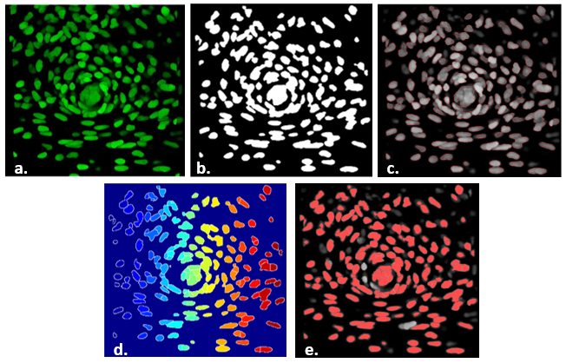
Figure ##: Pedro Segmentation Progression a. b. c. d. e.
The basic morphological with watershed approach was sourced from a "Basic Cell Counting and Segmentation in Matlab" Guide which utilizes an in vivo cell image [cite Pedro][cite his reference image paper]. The code can be split into three sections: preparation, morphological, and watershed counting. In preparation, the image is converted to grayscale, multiple filters are applied to remove noise, and contrast adjustments are made to enhance cells that appear dimmer. The morphological section involves identifying the perimeters of individual cells and/or cell groups, finding the global image threshold through Otsu's method, and binarizing the image. Since the cells had internal contrast variations, image regions and holes were filled. A morphological opening of the image is then performed and a disk-shaped structuring element is constructed which helps to further eliminate any unwanted or erroneous connected cell structures. This is followed by overlaying the greyscale, filtered, and binarized images which obtain an image of cells and cell groups being identified with a red outline. Although the code can capture most of the cells, there will not be an accurate counting of grouped cells and therefore a watershed algorithm is used. The watershed enables the user to separate the groups into individual cells to an extent. Then, the algorithm is able to translate the level/intensity of pixels as an altitude of a relief. In doing so, the user then has to adjust the image to ensure that the cell "walls" feature the greatest pixel intensity. In what would be characterized as the highly-intense cell nucleus, such maximums are downgraded to local minima, allowing for the walls to take precedence in pixel intensity. Once the watershed is fully applied, the cells can be detected, counted, and masked to an overlay of the original image to validate identifications. This was the preferred approach and one that was built upon for further testing and application for this research project's uses. See Section #.# for the further work completed with this scripting option.

2.2 Image Segmenter App
Utilizing the Image Segmenter App is a much more hands-on approach. It is either executed in the Apps tab or initiated in a script after reading an image. With the read image loaded, a user can toggle the type of threshold applied and its sensitivity as well as finding circles through entering diameters and sensitivity. One may describe the Image Segmenter App as the manual breakdown of what the previously discussed morphological code performs. Once the user is satisfied with the threshold applied to the image loaded, a mask can be created or the image can be binarized.

<Need to include test images from Pedro implemented into this app, and demonstrate different sensitivities with figures>

While it can be a useful tool to cross-reference what the automated algorithms of the first approach outputs, this ultimately would not satisfy the goal of a seamlessly automated and interfaced script.

2.3 Granulometry | Granulometry of Snowflakes
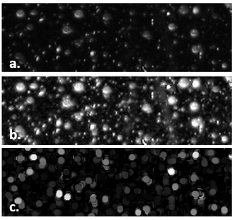
Figure ##: Snowflake Granulometry Progression - a. b. c.
The granulometry path had looked initially promising through the MATLAB "Granulometry of Snowflakes" example. Unlike the previous two approaches, granulometry finds the object size distribution in a given image, without having to first detect each individual object. This is done by first maximizing the intensity contrast of the image through a "contrast-limited adaptive histogram equalization" function known as adapthisteq. The intensity surface area (ISA) distribution is then estimated through use of a structuring element (the same disk used in the first approach) that increases in size and counts the remaining ISA after every new element is applied. One can think of granulometry "seeing" the image objects as diversely-sized rocks and then using sifts of increasing sizes to sort them. From there, the code takes the first derivative of the size distribution and then is able to extract objects with a specified radius. One can see in Figure ## how the darkened image of snowflake granules, became an image of clusters of dots, with desired ones whited-out.

2.4 Edge Detection | Detect Cell Using Edge Detection and Morphology
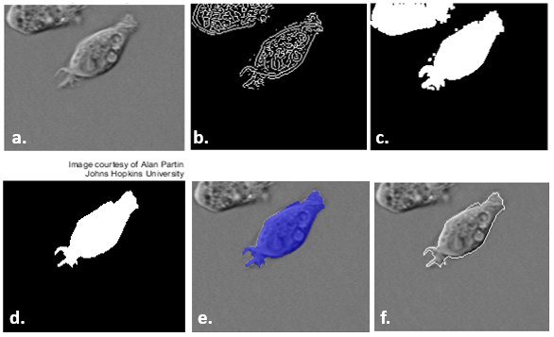
Figure ##: Edge Detection Progression – a. b. c. d. e. f.
The fourth approach using edge detection combined techniques from the previous three options. A Sobel operator was used in parallel with the edge function to find the threshold value. In short, Sobel institutes a gradient matrix for each pixel in the image. Values are compared for the x and y planes, and the higher the difference, the more likely an edge occurs at that pixel location. With Sobel completed, a binary mask is applied to observe the contrast difference of the image. Then, the cell of interest is filled ("whited-out"), the border is cleared of any straying foreign objects, and the fill is smoothed with a diamond structuring element. Finally, the smoothed mask is overlayed with the original image or an outline is drawn around the cell in the original image utilizing the data from the smoothed mask. <insert images from original to filled, to mask over and outline option>

The Wiener filter, er type utilizes that will "smooth"

Integration & Results
As mentioned previously in Sec. #.#, the goal was to progressively adjust the scripts as necessary to identify cells of three different images; first the original image, then a PNAS image, and finally an image from Dr. Wynne’s laboratory. By doing so, repeatability would verify the success of such code. * Save for other part…Since Pedro’s segmentation code was the foundational code of choice, there were several variations based off of it

3.1 Pedro Segmentation

3.1.1 Sample Code Verification | BasicCellSegm_PedroFoundational
The intial sample code was written in the “BasicCellSegm_PedroFoundational” script and tested. Since the original image size varied by browser download and screen size, it was not fully identical to the one used in [cite Pedro]. The only effect such a deviation had on the validation was the effective number of cells counted by the algorithm. There were 199 cells counted instead of 185 cells, and thus some clusters might have been over-segmented. As seen in Figure ##.## below, it was valid to declare the sample code as functional. It should be noted that even in [], not all visible cells were identified. It is certainly not a perfect algorithm, but one to build upon.
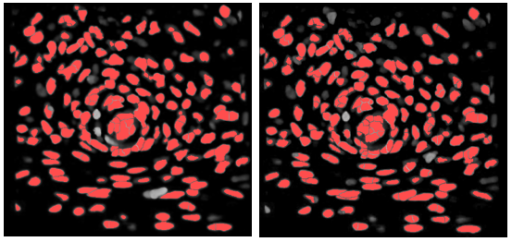
Figure #.#: Comparison of Example Code Results to BasicCellSegm_PedroFoundational – Left: Pedro Example Right: BasicCellSegm_PedroFoundational

3.1.2 PNAS Images Implementation
The next step was implementing select images from [cite PNAS paper]. As one will observe in the below figures, images with different variations of cell sizes, shapes, and contrasts were chosen to help fine-tune the algorithm. Pedro’s Segmentation code was optimized for one sample image, and when other images were tested with it, the identification success rate was mixed. Interesting observations were made with the following four images selected from [].
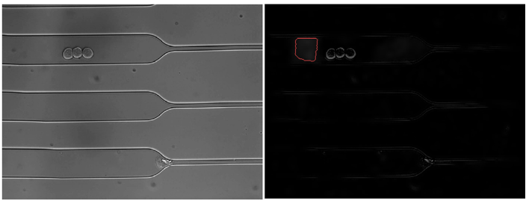

Figure #.#: pnasimage1 Implementation

Pedro’s segmentation failed to identify any of the cells in pnasimage1, and instead circled a boxed shadow next to the well-defined cluster of three cells as seen above in Fig. #. Further work was performed on pnasimage1 in Section #.#.
The code’s performance improved with pnasimage2 and it was able to differentiate between the clusters of cells for the most part as seen below in Figure #. Since the cells were illuminated a neon green color that paralleled the original sample image coloration, it was likely the detections might be more successful. For part a of pnasimage2, the large clump outlines were correctly detected with some variation while the grayer cells were missed. This detection performance was relatively consistent for parts b and c. In some cases, grayer cells had only their “nucleus” identified since the walls did not contrast the black background enough.
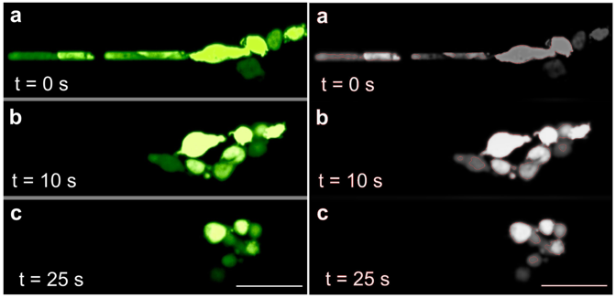

Figure #: pnasimage2 Implementation

Despite the relative success with pnasimage2, the script’s detection failed to mark any significant cells in pnasimage3 and pnasimage4. In pnasimage3, mostly shadow clumps were detected. A half-crescent identification in the right middle segment of figure #, was the closest the program reached to detecting a full cell. While pnasimage4 had the same detection fate, there were some merits to the performance. The top part a had more cell-like structures than the veiny bottom part b, however more accurate detections were found in the latter. In regards to shadow identifications, both parts had their share of shadows being falsely counted, but there were no similar attributes between them; it was truly a “luck of the draw.”
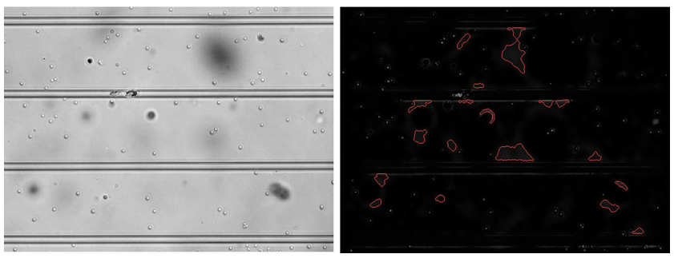

Figure #: pnasimage3 Implementation

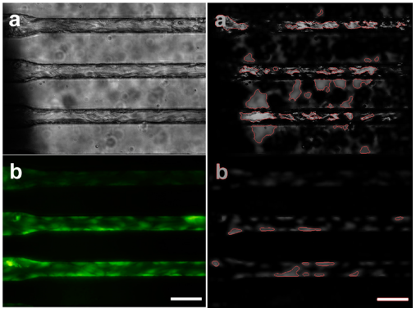

Figure #: pnasimage4 Implementation

3.1.3 pnasimage1-focused Experimentation
Out of the four implemented images, it was decided that pnasimage1 would be the image of choice to further experiment with. This was since it featured a clearly-defined cluster of cells that were few enough to hypothetically make initial tuning less complex. The goal from here was to reach full successful detection of the three cells previously observed in figure # and build upon such.
There were multiple paths taken to attempt to have the script correctly identify the three cells. The most obvious path was first toggling with the available controls such as threshold, the window pixel size of the wiener filtering, and the pixel constraints of connected components to be removed. While the threshold was being automatically generated, one could look through the “graythresh” function lines in the very bottom of the MATLAB script editor window. There was not much flexibility and it proved to be a dead end. Adjusting the window pixel size of the wiener filtering definitely had more of an immediate effect, however, the script still mis-detected the shadow for cells. A maxed-out window of 1000 x 1000 and a minimized window of 1 x 1 was observed to verify variability controls. Then, slight deviations were introduced from the original 5x5 window defined in Pedro’s script. Unfortunately, there were only changes to how the shadow outline was structured, not any movement to outline the cells. Progressively increasing and decreasing the pixel constraints of the connected components followed suit, only slightly variating how the shadow was outlined. * be sure to include figures if possible
It was thought that the too slim of a contrast difference might be the main issue causing the cells not to be correctly identified. Thus, a grayscale image lighting enhancement tool was implemented into the script. The aforementioned tool applies maximum and minimum filters to help increase the contrast difference between the foreground cells and the darker background. Through a Gaussian filter, the background is then smoothed, preparing it for the binarization and circle fills that Pedro’s scripting performs. Applying a bright or dark input for the background image yields the results seen in figure # below.
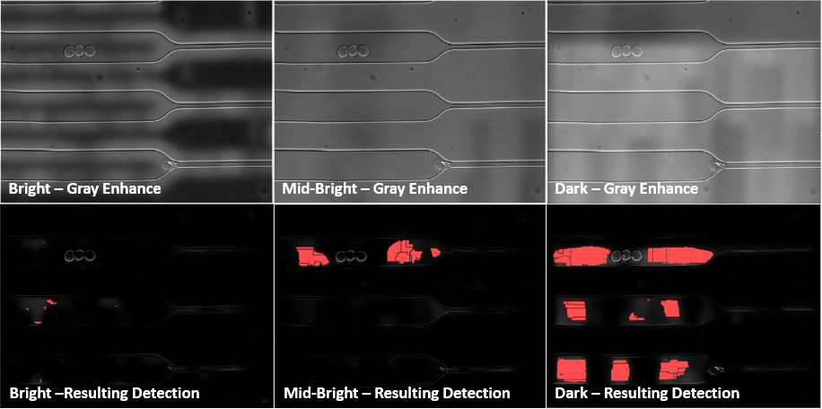

Figure #: Grayscale Enhancement & Detection

The tool’s efficiency was not as valuable as originally hoped. Declaring the background as bright, in hopes of having a darker contrast eliminated the boxed shadow detection, but still missed the three cells. The darker the background declaration in the script, the closer the identification came to detecting the three cells-yet, it was all boxed shadows being counted on either side of the cells. Tiny red blots can be observed in two of the cells, however that was the closest the script got to detecting them.
The final path attempted was removing the watershed algorithm and the third overlay. It was thought that this might be an unnecessary part of the script, and useful to explore the option. With only commenting out the watershed algorithm and the overlay3 that followed or ending the script with imshow(overlay2), the detection seemed to improve. As seen in figure #, the script finally was able to identify the three cells a bit.
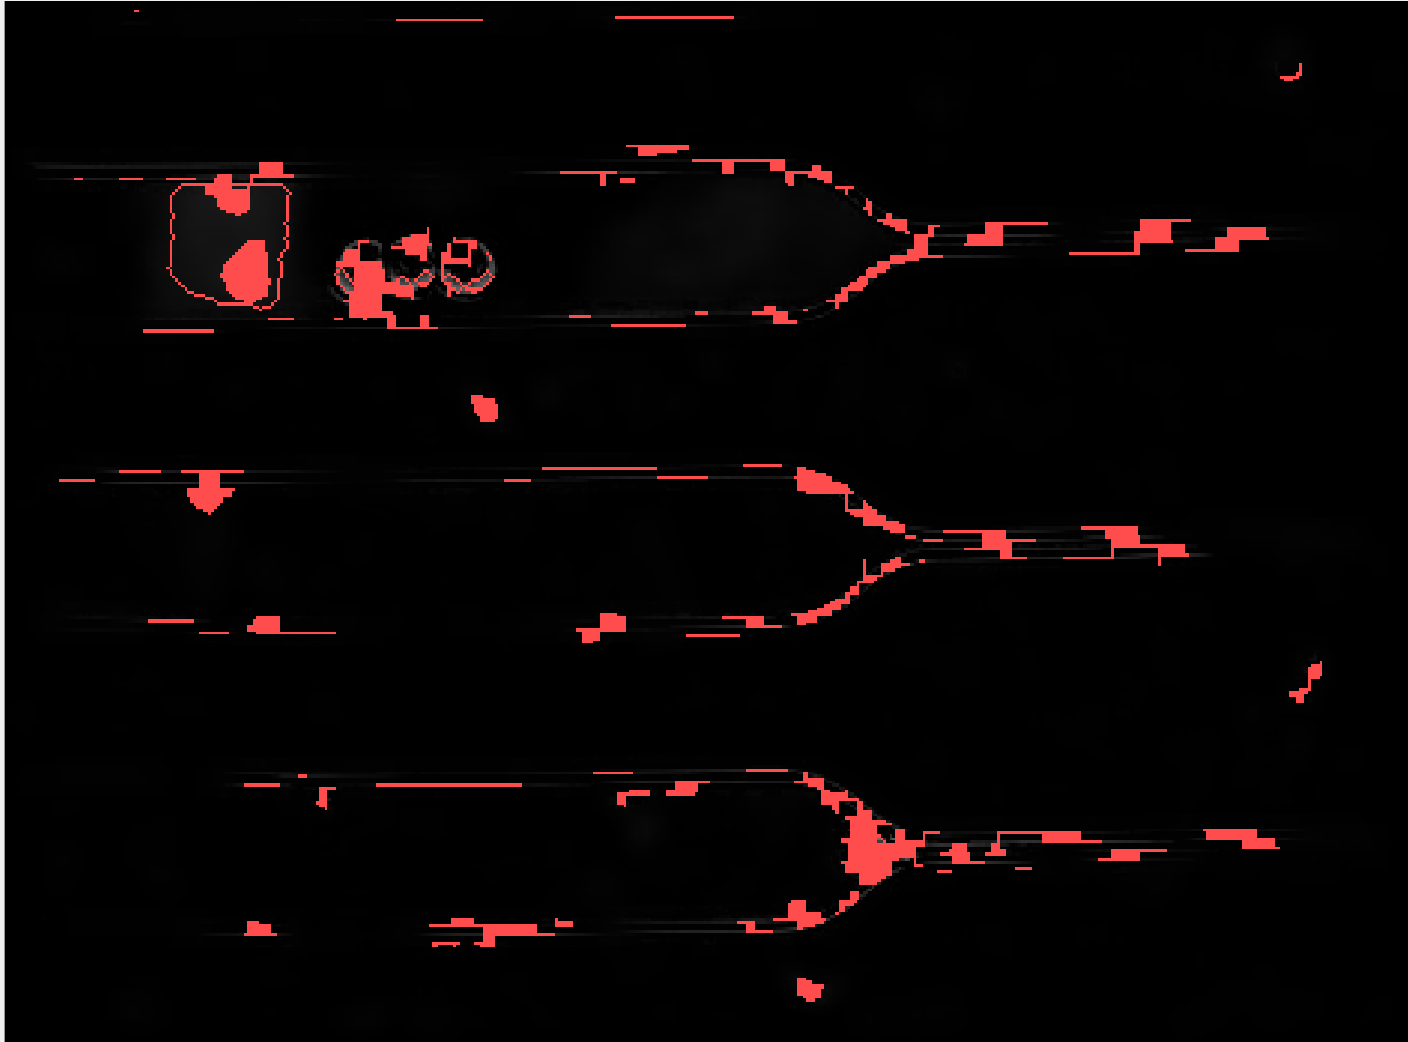

Figure #: Watershed Removal Result

Then, the grayscale image lighting tool was implemented with the removal of the watershed algorithm. As seen in figure #, grayscale lighting enhancement hindered the detection, creating more noise and random shadow identifications. The cells were further filled in, however the added noise outweighed the progress.
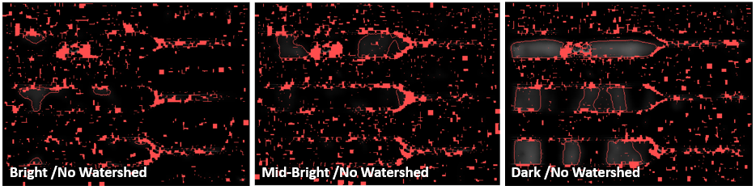

Figure #: Grayscale Enhancement without Watershed

3.2 Other

3.2.1 Image Segmenter App
Running the Image Segmenter App with the original image from Pedro’s segmentation example provided some insight into different thresholding. Interestingly enough, the global threshold (Otsu’s method) only captured parts of a few cells. The differentiating threshold results can be observed in figure #, where it is evident that the manual threshold set at 23 and adaptive threshold with at 95 sensitivity produced the most accurate identifications.
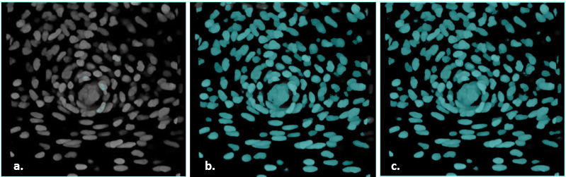
Figure #: Image Segmenter App Threshold Experimentation –
- Global (Otsu’s) b. Adaptive (set at 95 sensitivity) c. Manual (23 threshold)

The app’s “Find Circles” feature was also tested. Utilizing the ruler, minimum and maximum diameters were established to be 8.25 and 75 pixels, respectively. Unfortunately, no circles were detected.

3.2.2 Granulometry
From the onset, the granulometry sample code proved to be more tedious and less automatic than preferred. It was found that when utilizing the interactive code on MATLAB’s website, the Snowflake Granulometry example performed as intended. When implemented in MATLAB itself however, the granulometry code did not work consistently. It was found through forum discussion that the background scripts behind the main script were not updated, and thus, for every new image loaded, one would have to update and adjust the background scripts to have the detection run properly. No further actions were taken with this path at that point, since the goal of automatic detection was not satisfied.

3.2.3 Edge Detection
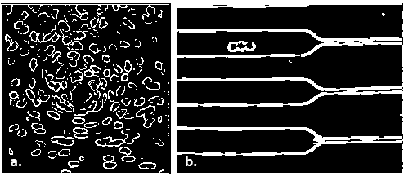
Figure #: Edge Detection Application -
a. Pedro Segmentation Sample with Edge Detection b. pnasimage1 with Edge Detection

The edge detection route yielded some promising results. As seen above in figure #, the edge detection script was able to identify almost, if not all of the cells in Pedro’s sample image. When testing pnasimage1, the three cells were identified for the most part (more than any other method had achieved previously), however the channels were also mistakenly identified. Time constraints prevented further work with edge detection, however Section 4 outlines what future research with it might entail.

3.2.4 Dr. Wynne Lab Image Enhancement
When originally experimenting with Pedro’s segmentation, an enhancement edit was found to work on a lab image provided by Dr. Wynne. Observed in figure # below, the filtered image illuminates the cells more as well as the contrasting background.
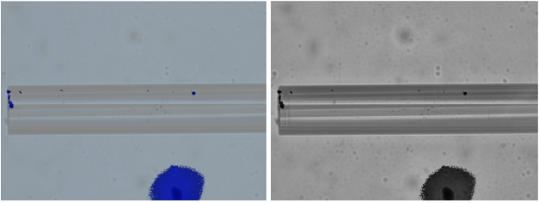
Figure #: Lab Image Enhancement – Left: Original Image from Dr. Wynne,
Right: Pedro Segmentation Filtering of Original Image

Discussion & Recommendations
While the aforementioned efforts of cell identification using MATLAB were not able to fully identify the target cells, much insight was gained. There is no single established method that can necessarily be applied, due to the variance of cell structure and image contrast. The four routes taken all had unique features that advertised being flexible to a certain extent, however once the efficiency of automation was ruled out, so was that respective path. From the start, it was quite apparent that what works for one image of cell clusters, wasn’t guaranteed to work for another image of different clusters. The peculiar part about utilizing pnasimage1 was how apparent the three cells were to the human eye, yet the algorithm was having a difficult time being trained to see the same. Every possible noise imaginable surrounding the cells in that image was able to be identified, despite the low contrast difference with the background. While performing image analysis, questions did surface that might point to detection inaccuracies. Such questions included: Was the filtered image returned as a numerical array, the same size as the original input image? Was the initial contrast difference of the image disrupting the filter performance? Was Pedro’s segmentation threshold too broad to detail the required images? While all were good questions, each had an answer. The nature of the algorithms themselves were to preserve the array size of the mask and the original image. Also, upon browsing the MATLAB sidebar and comparing the original image with its filtered mask, one found that the sizing was identical. If the initial contrast difference had been disrupting filter performance, then it would be assumed that the gray enhancement would have yielded a much-improved result. While the background was smoothed out in most cases, noise in the form of shadows was still being detected more than the cells themselves. Finally, it was relatively true that the threshold method Pedro’s segmentation utilized seemed too broad for pnasimage1, however this could be deducted for any of the threshold methods depending on the image at hand. In short, the variability and specificity involved made it difficult for there to be a common thread found amongst all scripts implemented, except for that the three clearly defined cells could not be identified.
Unfortunately, there was not enough time in this endeavor to explore further scripting and methodology to solve this unique challenge. It is recommended for future research that the edge detection path is implemented further and potentially combined with the foundational methods utilized by Pedro’s segmentation. As seen in figure #, edge detection was able to outline most of the three cells and could be a potential path with more research. After validating respectable accuracy with pnasimage1, it would then be suggested to try out Dr. Wynne’s lab images on the algorithm. In addition, further work is needed to address the efficiency of automation in the cell identification process. Features such as a user interface,,,,, unpacking the image…, interesting, SEG-SELF

Conclusions
Progress made, how it applied to learning, room for growth and building blocks for future research and lab assistance

